Topic | Proposed Direction
Movement of Commercial Bait (Purchased Bait) | 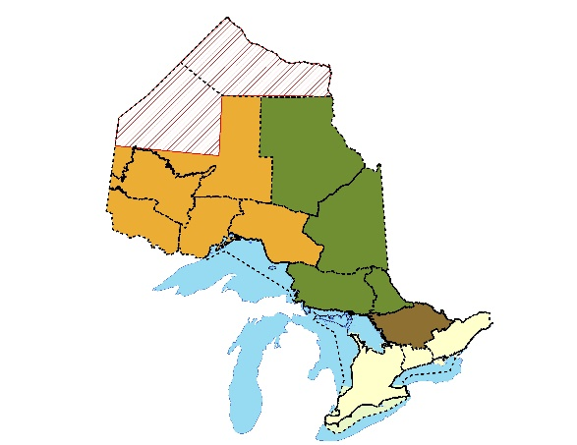
Movement exceptions | - Bait can be moved into Great Lakes from adjacent zones.  - Bait can be moved in/out of the Ottawa River from adjacent zones.
Implementation | - Anglers are required to keep receipts outside of the zone of their primary residence (home zone). Receipts expire after two weeks.  - Anglers are not required to keep receipts in their home zone.
Movement of Personally-Harvested Bait | 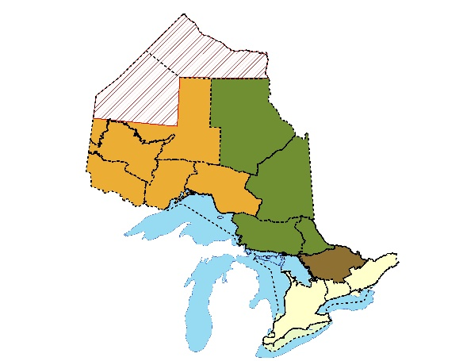
Implementation | - Personally- harvested bait can be used and moved in the anglers’ home zone.  - No additional bait licence or documentation is required.
Legal Species of bait | - 34 species allowed as bait.  - Brook Stickleback and Ninespine Sticklebacks are allowed.  - Banded Killifish are allowed.
Brook Trout | - The use and storage of bait are not allowed in native Brook Trout lakes.
Commercial topics | - Minimal changes are proposed to commercial topics (including compliance, reporting, gear types, licence terms, acquiring BHAs, etc.).

